3.9 TERMINALS
Every general purpose computer has one or more terminals used to communicate with it. Terminals come in an extremely large number of different forms. It is up to the terminal driver to hide all these differences, so that the device-independent part of the operating system and the user programs do not have to be rewritten for each kind of terminal. In the following sections we will follow our now-standard approach of first discussing terminal hardware and software in general, and then discussing the MINIX software.
3.9.1 Terminal Hardware
From the operating system's point of view, terminals can be divided into three broad categories based on how the operating system communicates with them. The first category consists of memory-mapped terminals, which consist of a keyboard and a display, both of which are hardwired to the computer. The second category consists of terminals that interface via a serial communication line using the RS-232 standard, most frequently over a modem. The third category consists of terminals that are connected to the computer via a network. This taxonomy is shown in Fig. 3-27.
Memory-Mapped Terminals
The first broad category of terminals named in Fig. 3-27 consists of memory-mapped terminals. These are an integral part of the computers themselves. Memory-mapped terminals are interfaced via a special memory called a video
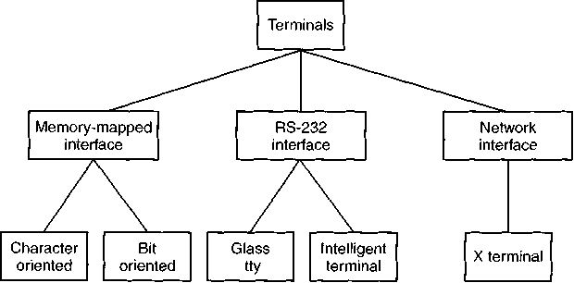

Figure 3-27. Terminal types.
RAM, which forms part of the computer's address space and is addressed by the CPU the same way as the rest of memory (see Fig. 3-28).
Also on the video RAM card is a chip called a video controller. This chip pulls character codes out of the video RAM and generates the video signal used to drive the display (monitor). The monitor generates a beam of electrons that scans horizontally across the screen, painting lines on it. Typically the screen has 480 to 1024 lines from top to bottom, with 640 to 1200 points per line. These points are called pixels. The video controller signal modulates the electron beam, determining whether a given pixel will be light or dark. Color monitors have three beams, for red, green, and blue, which are independently modulated.
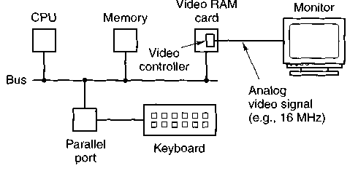

Figure 3-28. Memory-mapped terminals write directly into video RAM.
A simple monochrome display might fit each character in a box 9 pixels wide by 14 pixels high (including the space between characters), and have 25 lines of 80 characters. The display would then have 350 scan lines of 720 pixels each. Each of these frames is redrawn 45 to 70 times a second. The video controller could be designed to fetch the first 80 characters from the video RAM, generate 14 scan lines, fetch the next 80 characters from the video RAM, generate the following 14 scan lines, and so on. In fact, most fetch each character once per scan line to eliminate the need for buffering in the controller. The 9-by-14 bit patterns for the characters are kept in a ROM used by the video controller. (RAM may also be used to support custom fonts.) The ROM is addressed by a 12-bit address, 8 bits from the character code and 4 bits to specify a scan line. The 8 bits in each byte of the ROM control 8 pixels; the 9th pixel between characters is always blank. Thus 14x80= 1120 memory references to the video RAM are needed per line of text on the screen. The same number of references are made to the character generator ROM.
The IBM PC has several modes for the screen. In the simplest one, it uses a character-mapped display for the console. In Fig. 3-29(a) we see a portion of the video RAM. Each character on the screen of Fig. 3-29(b) occupies two characters in the RAM. The low-order character is the ASCII code for the character to be displayed. The high-order character is the attribute byte, which is used to specify the color, reverse video, blinking, and so on. The full screen of 25 by 80 characters requires 4000 bytes of video RAM in this mode.
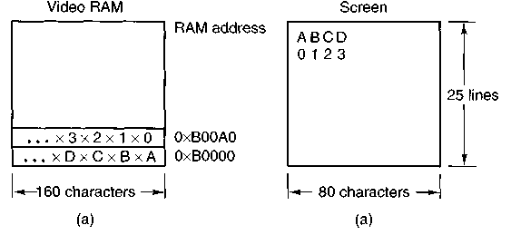

Figure 3-29. (a) A video RAM image for the IBM monochrome display. (b) The corresponding screen. The xs are attribute bytes.
Bit-map terminals use the same principle, except that each pixel on the screen is individually controlled. In the simplest configuration, for a monochrome display, each pixel has a corresponding bit in the video RAM. At the other extreme, each pixel is represented by a 24-bit number, with 8 bits each for red, green, and blue. A 768 * 1024 color display with 24 bits per pixel requires 2 MB of RAM just to hold the image.
With a memory-mapped display, the keyboard is completely decoupled from the screen. It may be interfaced via a serial or parallel port. On every key action the CPU is interrupted, and the keyboard driver extracts the character typed by reading an I/O port.
On the IBM PC, the keyboard contains an embedded microprocessor which communicates through a specialized serial port with a controller chip on the motherboard. An interrupt is generated whenever a key is struck and also when one is released. Furthermore, all that the keyboard hardware provides is the key number, not the ASCII code. When the A key is struck, the key code (30) is put in an I/O register. It is up to the driver to determine whether it is lower case, upper case, CTRL-A, ALT-A, CTRL-ALT-A, or some other combination. Since the driver can tell which keys have been struck but not yet released (e.g., shift), it has enough information to do the job. Although this keyboard interface puts the full burden on the software, it is extremely flexible. For example, user programs may be interested in whether a digit just typed came from the top row of keys or the numeric key pad on the side. In principle, the driver can provide this information.
RS-232 Terminals
RS-232 terminals are devices containing a keyboard and a display that communicate using a serial interface, one bit at a time (see Fig. 3-30). These terminals use a 9-pin or 25-pin connector, of which one pin is used for transmitting data, one pin is for receiving data, and one pin is ground. The other pins are for various control functions, most of which are not used. To send a character to an RS-232 terminal, the computer must transmit it 1 bit at a time, prefixed by a start bit, and followed by 1 or 2 stop bits to delimit the character. A parity bit which provides rudimentary error detection may also be inserted preceding the stop bits, although this is commonly required only for communication with mainframe systems. Common transmission rates are 9600, 19,200, and 38,400 bps. RS-232 terminals are commonly used to communicate with a remote computer using a modem and a telephone line.
Computer
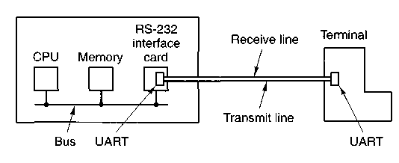

Figure 3-30. An RS-232 terminal communicates with a computer over a communication line, one bit at a time. The computer and the terminal are completely independent.
Since both computers and terminals work internally with whole characters but must communicate over a serial line a bit at a time, chips have been developed to do the character-to-serial and serial-to-character conversions. They are called UARTs (Universal Asynchronous Receiver Transmitters). UARTs are attached to the computer by plugging RS-232 interface cards into the bus as illustrated in Fig. 3-31. RS-232 terminals are gradually dying off, being replaced by PCs and X terminals, but they are still encountered on older mainframe systems, especially in banking, airline reservation, and similar applications.
To print a character, the terminal driver writes the character to the interface card, where it is buffered and then shifted out over the serial line one bit at a time by the UART. Even at 38,400 bps, it takes just over 250 microsec to send a character. As a result of this slow transmission rate, the driver generally outputs a character to the RS-232 card and blocks, waiting for the interrupt generated by the interface when the character has been transmitted and the UART is able to accept another character. The UART can simultaneously send and receive characters, as its name implies. An interrupt is also generated when a character is received, and usually a small number of input characters can be buffered. The terminal driver must check a register when an interrupt is received to determine the cause of the interrupt. Some interface cards have a CPU and memory and can handle multiple lines, taking over much of the I/O load from the main CPU.
RS-232 terminals can be subdivided into categories, as mentioned above. The simplest ones were hardcopy (printing) terminals. Characters typed on the keyboard were transmitted to the computer. Characters sent by the computer were typed on the paper. These terminals are obsolete and rarely seen any more.
Dumb CRT terminals work the same way, only with a screen instead of paper. These are often called "glass ttys" because they are functionally the same as hardcopy ttys. (The term "tty" is an abbreviation for Teletype a former company that pioneered in the computer terminal business; "tty" has come to mean any terminal.) Glass ttys are also obsolete.
Intelligent CRT terminals are in fact miniature, specialized computers. They have a CPU and memory and contain software, usually in ROM. From the operating system's viewpoint, the main difference between a glass tty and an intelligent terminal is that the latter understands certain escape sequences. For example, by sending the ASCII ESC character (033), followed by various other characters, it may be possible to move the cursor to any position on the screen, insert text in the middle of the screen, and so forth.
X Terminals
The ultimate in intelligent terminals is a terminal that contains a CPU as powerful as the main computer, along with megabytes of memory, a keyboard, and a mouse. One common terminal of this type is the X terminal, which runs M.I.T.'s X Window System. Usually, X terminals talk to the main computer over an Ethernet.
An X terminal is a computer that runs the X software. Some products are dedicated to running only X; others are general-purpose computers that simply run X as one program among many others. Either way, an X terminal has a large bitmapped screen, usually 960 * 1200 or better resolution, in black and white, grayscale, or color, a full keyboard, and a mouse, normally with three buttons.
The program inside the X terminal that collects input from the keyboard or mouse and accepts commands from a remote computer is called the X server. It communicates over the network with X clients running on some remote host. It may seem strange to have the X server inside the terminal and the clients on the remote host, but the X server's job is to display bits, so it makes sense to be near the user. The arrangement of client and server is shown in Fig. 3-31.
X terminal
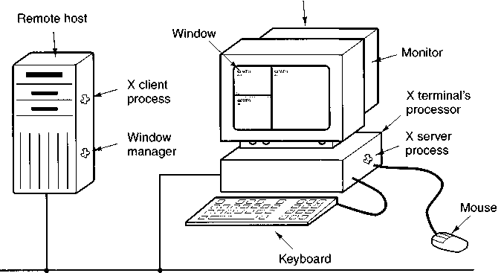

Network
Figure 3-31. Clients and servers in the M.I.T. X Window System.
The screen of the X terminal contains some number of windows, each in the form of a rectangular grid of pixels. Each window usually has a title bar at the top, a scroll bar on the left, and a resizing box in the upper right-hand corner. One of the X clients is a program called a window manager. Its job is to control the creation, deletion, and movement of windows on the screen. To manage windows, it sends commands to the X server telling what to do. These commands include draw point, draw line, draw rectangle, draw polygon, fill rectangle, fill polygon, and so on.
The job of the X server is to coordinate input from the mouse, keyboard, and X clients and update the display accordingly. It has to keep track of which window is currently selected (where the mouse pointer is), so it knows which client to send any new keyboard input to.
3.9.2 Terminal Software
The keyboard and display are almost independent devices, so we will treat them separately here. (They are not quite independent, since typed characters must be displayed on the screen.) In MINIX the keyboard and screen drivers are part of the same task; in other systems they may be split into distinct drivers.
Input Software
The basic job of the keyboard driver is to collect input from the keyboard and pass it to user programs when they read from the terminal. Two possible philosophies can be adopted for the driver. In the first one, the driver's job is just to accept input and pass it upward unmodified. A program reading from the terminal gets a raw sequence of ASCII codes. (Giving user programs the key numbers is too primitive, as well as being highly machine dependent.)
This philosophy is well suited to the needs of sophisticated screen editors such as emacs, which allow the user to bind an arbitrary action to any character or sequence of characters. It does, however, mean that if the user types dste instead of date and then corrects the error by typing three backspaces and ate, followed by a carriage return, the user program will be given all 11 ASCII codes typed.
Most programs do not want this much detail. They just want the corrected input, not the exact sequence of how it was produced. This observation leads to the second philosophy: the driver handles all the intraline editing, and just delivers corrected lines to the user programs. The first philosophy is character-oriented; the second one is line-oriented. Originally they were referred to as raw mode and cooked mode, respectively. The POSIX standard uses the less-picturesque term canonical mode to describe line-oriented mode. On most systems canonical mode refers to a well-defined configuration. Noncanonical mode is equivalent to raw mode, although many details of terminal behavior can be changed. POSIX-compatible systems provide several library functions that support selecting either mode and changing many aspects of terminal configuration. In MINIX the IOCTL system call supports these functions.
The first task of the keyboard driver is to collect characters. If every keystroke causes an interrupt, the driver can acquire the character during the interrupt. If interrupts are turned into messages by the low-level software, it is possible to put the newly acquired character in the message. Alternatively, it can be put in a small buffer in memory and the message used to tell the driver that something has arrived. The latter approach is actually safer if a message can be sent only to a waiting process and there is some chance that the keyboard driver might still be busy with the previous character.
Once the driver has received the character, it must begin processing it. If the keyboard delivers key numbers rather than the character codes used by application software, then the driver must convert between the codes by using a table. Not all IBM "compatibles" use standard key numbering, so if the driver wants to support these machines, it must map different keyboards with different tables. A simple approach is to compile a table that maps between the codes provided by the keyboard and ASCII (American Standard Code for Information Interchange) codes into the keyboard driver, but this is unsatisfactory for users of languages other than English. Keyboards are arranged differently in different countries, and the ASCII character set is not adequate even for the majority of people in the Western Hemisphere, where speakers of Spanish, Portuguese, and French need accented characters and punctuation marks not used in English. To respond to the need for flexibility of keyboard layouts to provide for different languages, many operating systems provide for loadable keymaps or code pages, which make it possible to choose the mapping between keyboard codes and codes delivered to the application, either when the system is booted or later.
If the terminal is in canonical (cooked) mode, characters must be stored until an entire line has been accumulated, because the user may subsequently decide to erase part of it. Even if the terminal is in raw mode, the program may not yet have requested input, so the characters must be buffered to allow type ahead. (System designers who do not allow users to type far ahead ought to be tarred and feathered, or worse yet, be forced to use their own system.)
Two approaches to character buffering are common. In the first one, the driver contains a central pool of buffers, each buffer holding perhaps 10 characters. Associated with each terminal is a data structure, which contains, among other items, a pointer to the chain of buffers for input collected from that terminal. As more characters are typed, more buffers are acquired and hung on the chain. When the characters are passed to a user program, the buffers are removed and put back in the central pool.
The other approach is to do the buffering directly in the terminal data structure itself, with no central pool of buffers. Since it is common for users to type a command that will take a little while (say, a compilation) and then type a few lines ahead, to be safe the driver should allocate something like 200 characters per terminal. In a large-scale timesharing system with 100 terminals, allocating 20K all the time for type ahead is clearly overkill, so a central buffer pool with space for perhaps 5K is probably enough. On the other hand, a dedicated buffer per terminal makes the driver simpler (no linked list management) and is to be preferred on personal computers with only one or two terminals. Figure 3-32 shows the difference between these two methods.
Although the keyboard and display are logically separate devices, many users have grown accustomed to seeing the characters they have just typed appear on the screen. Some (older) terminals oblige by automatically displaying (in hardware) whatever has just been typed, which is not only a nuisance when passwords are being entered but greatly limits the flexibility of sophisticated editors and other programs. Fortunately, most modern terminals display nothing when keys are typed. It is therefore up to the software to display the input. This process is called echoing.
Echoing is complicated by the fact that a program may be writing to the screen while the user is typing. At the very least, the keyboard driver has to figure out where to put the new input without it being overwritten by program output.
Echoing also gets complicated when more than 80-characters are typed on a terminal with 80-character lines. Depending on the application, wrapping around to the next line may be appropriate. Some drivers just truncate lines to 80 characters by throwing away all characters beyond column 80.
Another problem is tab handling. Most terminals have a tab key, but few can handle tab on output. It is up to the driver to compute where the cursor is currently located, taking into account both output from programs and output from echoing, and compute the proper number of spaces to be echoed.

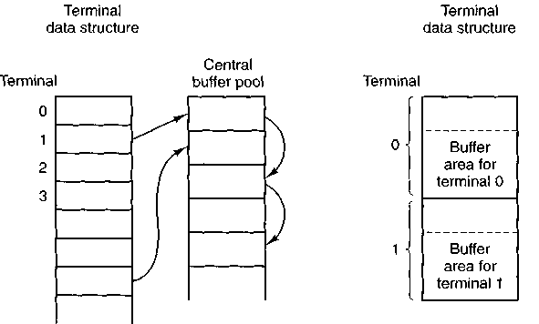

Figure 3-32. (a) Central buffer pool. (b) Dedicated buffer for each terminal.
Now we come to the problem of device equivalence. Logically, at the end of a line of text, one wants a carriage return, to move the cursor back to column 1, and a linefeed, to advance to the next line. Requiring users to type both at the end of each line would not sell well (although some terminals have a key which generates both, with a 50 percent chance of doing so in the order that the software wants them). It is up to the driver to convert whatever comes in to the standard internal format used by the operating system.
If the standard form is just to store a linefeed (the MINIX convention), then carriage returns should be turned into linefeeds. If the internal format is to store both, then the driver should generate a linefeed when it gets a carriage return and a carriage return when it gets a linefeed. No matter what the internal convention, the terminal may require both a linefeed and a carriage return to be echoed in order to get the screen updated properly. Since a large computer may well have a wide variety of different terminals connected to it, it is up to the keyboard driver to get all the different carriage return/linefeed combinations converted to the internal system standard and arrange for all echoing to be done right.
A related problem is the timing of carriage return and linefeeds. On some terminals, it may take longer to display a carriage return or linefeed than a letter or number. If the microprocessor inside the terminal actually has to copy a large block of text to achieve scrolling, then linefeeds may be slow. If a mechanical print head has to be returned to the left margin of the paper, carriage returns may be slow. In both cases it is up to the driver to insert filler characters (dummy null characters) into the output stream or just stop outputting long enough for the terminal to catch up. The amount of time to delay is often related to the terminal speed, for example, at 4800 bps or slower, no delays may be, but at 9600 bps or higher one filler character might be required. Terminals with hardware tabs, especially hardcopy ones, may also require a delay after a tab.
When operating in canonical mode, a number of input characters have special meanings. Figure 3-33 shows all of the special characters required by POSIX and the additional ones recognized by MINIX. The defaults are all control characters that should not conflict with text input or codes used by programs, but all except the last two can be changed using the stty command, if desired. Older versions of UNIX used different defaults for many of these.
Character | POSIX name | Comment
CTRL-D | EOF | End of file
 | EOL | End of line (undefined)
CTRL-H | ERASE | Backspace one character
DEL | INTR | Interrupt process (SIGINT)
CTRL-U | KILL | Erase entire line being typed
CTRL-\ | QUIT | Force core dump (SIGQUIT)
CTRL-Z | SUSP | Suspend (ignored by MINIX)
CTRL-Q | START | Start output
CTRL-S | STOP | Stop output
CTRL-R | REPRINT | Redisplay input (MINIX extension)
CTRL-V | LNEXT | Literal next (MINIX extension)
CTRL-O | DISCARD | Discard output (MINIX extension)
CTRL-M | CR | Carriage return (unchangeable)
CTRL-J | NL | Linefeed (unchangeable)
Figure 3-33. Characters that are handled specially in canonical mode.
The ERASE character allows the user to rub out the character just typed. In MINIX it is the backspace (CTRL-H). It is not added to the character queue but instead removes the previous character from the queue. It should be echoed as a sequence of three characters, backspace, space, and backspace, in order to remove the previous character from the screen. If the previous character was a tab, erasing it requires keeping track of where the cursor was prior to the tab. In most systems, backspacing will only erase characters on the current line. It will not erase a carriage return and back up into the previous line.
When the user notices an error at the start of the line being typed in, it is often convenient to erase the entire line and start again. The KILL character (in MINIX CTRL-U) erases the entire line. MINIX makes the erased line vanish from the screen, but some systems echo it plus a carriage return and linefeed because some users like to see the old line. Consequently, how to echo KILL is a matter of taste. As with ERASE it is usually not possible to go further back than the current line. When a block of characters is killed, it may or may not be worth the trouble for the driver to return buffers to the pool, if one is used.
Sometimes the ERASE or KILL characters must be entered as ordinary data. The LNEXT character serves as an escape character. In MINIX CTRL-V is the default. As an example, older UNIX systems often used the @ sign for KILL, but the Internet mail system uses addresses of the form linda@cs.washington.edu. Someone who feels more comfortable with older conventions might redefine KILL as @, but then need to enter an @ sign literally to address e-mail. This can be done by typing CTRL-V @. The CTRL-V itself can be entered literally by typing CTRL-V CTRL-V. After seeing a CTRL-V, the driver sets a flag saying that the next character is exempt from special processing. The LNEXT character itself is not entered in the character queue.
To allow users to stop a screen image from scrolling out of view, control codes are provided to freeze the screen and restart it later. In MINIX these are STOP, (CTRL-S) and START, (CTRL-Q), respectively. They are not stored but are used to set and clear a flag in the terminal data structure. Whenever output is attempted, the flag is inspected. If it is set, no output occurs. Usually, echoing is also suppressed along with program output.
It is often necessary to kill a runaway program being debugged. The INTR (DEL) and QUIT (CTRL-\) characters can be used for this purpose. In MINIX, DEL sends the SIGINT signal to all the processes started up from the terminal. Implementing DEL can be quite tricky. The hard part is getting the information from the driver to the part of the system that handles signals, which, after all, has not asked for this information. CTRL-\ is similar to DEL, except that it sends the SIGQUIT signal, which forces a core dump if not caught or ignored. When either of these keys is struck, the driver should echo a carriage return and linefeed and discard all accumulated input to allow for a fresh start. The default value for INTR is often CTRL-C instead of DEL, since many programs use DEL interchangeably with the backspace for editing.
Another special character is EOF (CTRL-D), which in MINIX causes any pending read requests for the terminal to be satisfied with whatever is available in the buffer, even if the buffer is empty. Typing CTRL-D at the start of a line causes the program to get a read of 0 bytes, which is conventionally interpreted as end-of-file and causes most programs to act the same way as they would upon seeing end-of-file on an input file.
Some terminal drivers allow much fancier intraline editing than we have sketched here. They have special control characters to erase a word, skip backward or forward characters or words, go to the beginning or end of the line being typed, and so forth. Adding all these functions to the terminal driver makes it much larger and, furthermore, is wasted when using fancy screen editors that work in raw mode anyway.
To allow programs to control terminal parameters, POSIX requires that several functions be available in the standard library, of which the most important are tcgetattr and tcsetattr. Tcgetattr retrieves a copy of the structure shown in Fig. 3-34, the termios structure, which contains all the information needed to change special characters, set modes, and modify other characteristics of a terminal. A program can examine the current settings and modify them as desired. Tcsetattr then writes the structure back to the terminal task.

struct termios {
tcflag_t c_iflag; /* input modes*/
tcflag_t c_oflag; /* output modes*/
tcflag_t c_cflag; /* control modes*/
tcflag_t c_lflag; /* local modes */
speed_t c_ispeed; /* input speed */
speed_t c_ospeed; /* output speed */
cc_t c_cc[NCCS]; /* control characters */
};
Figure 3-34. The termios structure. In minix tc_flag_t is a short, speed_t is an int, cc_t is a char.
POSIX does not specify whether its requirements should be implemented through library functions or system calls. MINIX provides a system call, IOCTL, called by
ioctl(file_descriptor, request, argp);
that is used to examine and modify the configurations of many I/O devices. This call is used to implement the tcgetattr and tcsetattr functions. The variable request specifies whether the termios structure is to be read or written, and in the latter case, whether the request is to take effect immediately or should be deferred until all currently queued output is complete. The variable argp is a pointer to a termios structure in the calling program. This particular choice of communication between program and driver was chosen for its UNIX compatibility, rather than for its inherent beauty.
A few notes about the termios structure are in order. The four flag words provide a great deal of flexibility. The individual bits in c_iflag control various ways input is handled. For instance, the ICRNL bit causes CR characters to be converted into NL on input. This flag is set by default in MINIX. The c_oflag holds bits that affect output processing. For instance, the OPOST bit enables output processing. It and the ONLCR bit, which causes NL characters in the output to be converted into a CR NL sequence, are also set by default in MINIX. The c_cflag is the control flag. The default settings for MINIX enable a line to receive 8-bit characters and cause a modem to hang up if a user logs out on the line. The c_lflag is the local mode flags field. One bit, ECHO, enables echoing (this can be turned off during a login to provide security for entering a password). Its most important bit is the ICANON bit, which enables canonical mode. With 1CANON off, several possibilities exist. If all other settings are left at their defaults, a mode identical to the traditional cbreak mode is entered. In this mode characters are passed to the program without waiting for a full line, but the INTR, QUIT, START, and STOP characters retain their effects. All of these can be disabled by resetting bits in the flags, however, to produce the equivalent of traditional raw mode.
The various special characters that can be changed, including those which are MINIX extensions, are held in the c_cc array. This array also holds two parameters which are used in noncanonical mode. The quantity MIN, stored in c_cc[VMIN], specifies the minimum number of characters that must be received to satisfy a READ call. The quantity TIME in c_cc[VTIME] sets a time limit for such calls. MIN and TIME interact as shown in Fig. 3-35. A call that asks for N bytes is illustrated. With TIME = 0 and MIN = 1, the behavior is similar to the traditional raw mode.
MIN = 0 | TIME = 0 | TIME > 0
MIN = 0 | Return immediately with whatever is available, 0 to N bytes | Timer starts immediately. Return with first byte entered or with 0 bytes after timeout
MIN > 0 | Return with at least MIN and up to N bytes. Possible indefinite block. | Interbyte timer starts after first byte. Return N bytes if received by timeout, or at least 1 byte at timeout. Possible indefinite block
Figure 3-35. MIN and TIME determine when a call to read returns in noncanonical mode. N is the number of bytes requested.
Output Software
Output is simpler than input, but drivers for RS-232 terminals are radically different from drivers for memory-mapped terminals. The method that is commonly used for RS-232 terminals is to have output buffers associated with each terminal. The buffers can come from the same pool as the input buffers, or be dedicated, as with input. When programs write to the terminal, the output is first copied to the buffers. Similarly, output from echoing is also copied to the buffers. After all the output has been copied to the buffers (or the buffers are full), the first character is output, and the driver goes to sleep. When the interrupt conies in, the next character is output, and so on.
With memory-mapped terminals, a simpler scheme is possible. Characters to be printed are extracted one at a time from user space and put directly in the video RAM. With RS-232 terminals, each character to be output is just sent across the line to the terminal. With memory mapping, some characters require special treatment, among them, backspace, carriage return, linefeed, and the audible bell (CTRL-G). A driver for a memory-mapped terminal must keep track in software of the current position in the video RAM, so that printable characters can be put there and the current position advanced. Backspace, carriage return, and linefeed all require this position to be updated appropriately.
In particular, when a linefeed is output on the bottom line of the screen, the screen must be scrolled. To see how scrolling works, look at Fig. 3-29. If the video controller always began reading the RAM at 0xB0000, the only way to scroll the screen would be to copy 24 x 80 characters (each character requiring 2 bytes) from 0xB00A0 to 0xB0000, a time-consuming proposition.
Fortunately, the hardware usually provides some help here. Most video controllers contain a register that determines where in the video RAM to begin fetching bytes for the top line on the screen. By setting this register to point to 0xB00A0 instead of 0xB0000, the line that was previously number two moves to the top, and the whole screen scrolls up one line. The only other thing the driver must do is copy whatever is needed to the new bottom line. When the video controller gets to the top of the RAM, it just wraps around and continues fetching bytes starting at the lowest address.
Another issue that the driver must deal with on a memory-mapped terminal is cursor positioning. Again, the hardware usually provides some assistance in the form of a register that tells where the cursor is to go. Finally, there is the problem of the bell. It is sounded by outputting a sine or square wave to the loudspeaker, a part of the computer quite separate from the video RAM.
It is worth noting that many of the issues faced by the terminal driver for a memory-mapped display (scrolling, bell, and so on) are also faced by the microprocessor inside an RS-232 terminal. From the viewpoint of the microprocessor, it is the main processor in a system with a memory-mapped display.
Screen editors and many other sophisticated programs need to be able to update the screen in more complex ways than just scrolling text onto the bottom of the display. To accommodate them, many terminal drivers support a variety of escape sequences. Although some terminals support idiosyncratic escape sequence sets, it is advantageous to have a standard to facilitate adapting software from one system to another. The American National Standards Institute (ANSI) has defined a set of standard escape sequences, and MINIX supports a subset of the ANSI sequences, shown in Fig. 3-36, that is adequate for many common operations. When the driver sees the character that starts the escape sequences, it sets a flag and waits until the rest of the escape sequence comes in. When everything has arrived, the driver must carry it out in software. Inserting and deleting text require moving blocks of characters around the video RAM. The hardware is of no help with anything except scrolling and displaying the cursor.
Escape sequence | Meaning
ESC[nA | Move up n lines
ESC[nB | Move down n lines
ESC[nC | Move right n spaces
ESC[nD | Move left n spaces
ESC[m;nH | Move cursor to (m,n)
ESC[sJ | Clear screen from cursor (0 to end, 1 from start, 2 all)
ESC[sK | Clear line from cursor (0 to end, 1 from start, 2 all)
ESC[nL | Insert n lines at cursor
ESC[nM | Delete n lines at cursor
ESC[nP | Delete n chars at cursor
ESC [ n @ | Insert n chars at cursor
ESC[nm | Enable rendition n (0=normal, 4=bold, 5=blinking, 7=reverse)
ESCM | Scroll the screen backward if the cursor is on the top line
Figure 3-36. The ANSI escape sequences accepted by the terminal driver on output. ESC denotes the ASCII escape character (0x1B), and n, m, and s are optional numeric parameters.

